USING ALL 5 SENSES FOR YOUR SPOOKY STORY . . .

Ever read a book so vivid that you actually feel like you’re there, experiencing everything right along with the characters? I have! It’s a great experience and one that reminds us that as writers, we should always strive to describe people and places in our stories as vividly as we can!
How can we do this? By using ALL 5 of our amazing senses, of course! What are the five senses?
- Sight
- Taste
- Touch
- Smell
- Sounds

Often, when we describe things, we rely on mainly our sight. That’s definitely important, but we have four other senses that can help us really create a full and lasting image for our reader! Let’s practice with a picture, shall we?

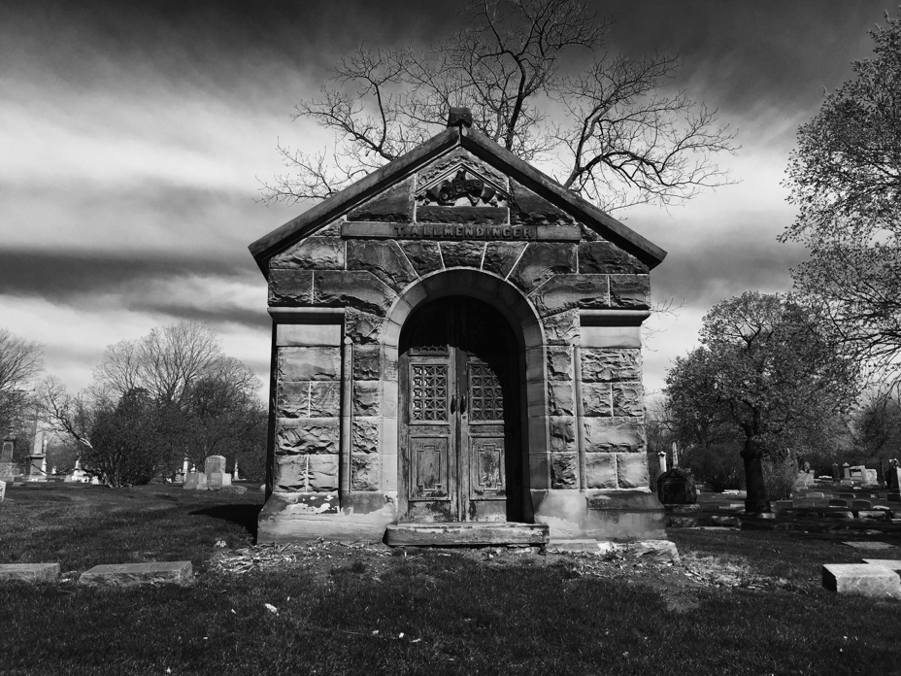
This picture was taken at Graceland cemetery, where many of the scenes in THE PECULIAR INCIDENT ON SHADY STREET take place. Examine the picture closely. What do you notice about it? Make a list of your observations. From your observations, determine what season you think the picture was taken in – does it look like it was warm outside, or do you think the air was crisp and chilly? What about the weather? Notice how every observation you make could be tied into one of your five senses to create a spooktacularly vivid scene!

Look at the picture again and imagine what it would feel like, smell like, sound like, to be standing in front of this mausoleum.

This is the first step to creating vivid, spooky scenes! Wanna see how I used all five of my senses in the graveyard to write a scene in PECULIAR INCIDENT?

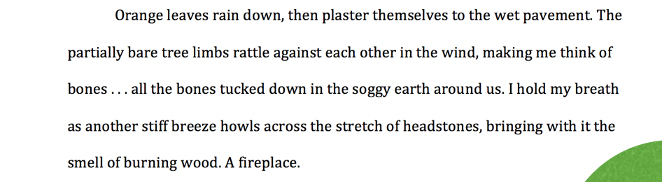

In the passage above, circle or highlight the five senses you see represented. Hint: 4 of the 5 senses are used. The missing sense might be a challenge to use in a graveyard

Now it’s your turn! Write your own paragraph based on any of the pictures below! Your senses might lead you to write something spooky, but they might not. Remember that the most important thing is making your reader feel like they are in the moment with your characters!

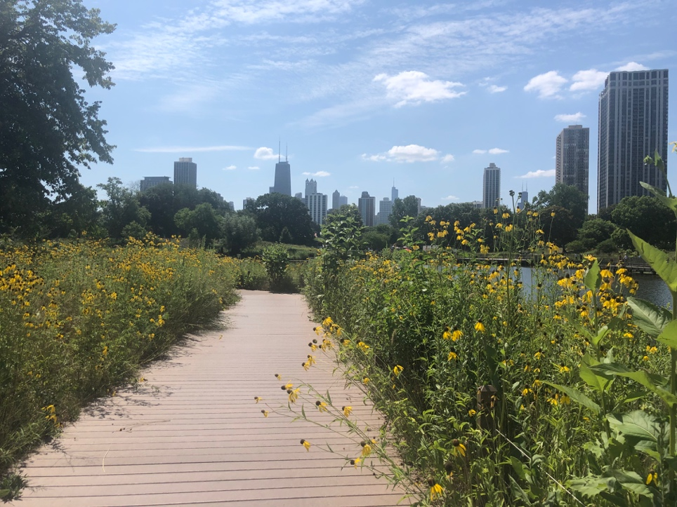
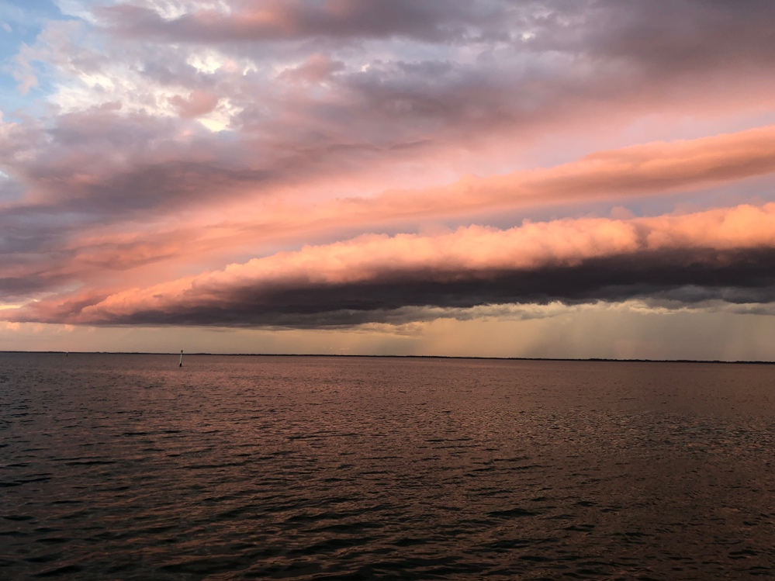
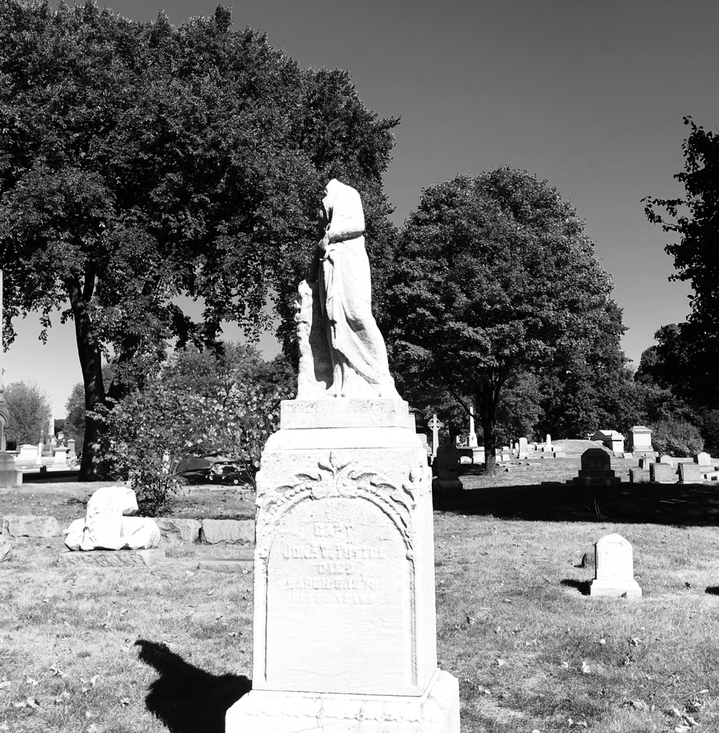

Awesome work, guys! I hope your five senses led you to some amazing descriptions! Don’t forget to check out the other activities and writing prompts in the SPOOKY 101 toolbox!

